

**FACULTY OF COMPUTER SYSTEMS & SOFTWARE ENGINEERING**

**Group Assignment**

# BCS1133 – SYSTEMS ANALYSIS & DESIGN

SECTION : 01

LECTURER : EN ZULFAHMI TOH

|  |  |  |
| --- | --- | --- |
| NO | NAME | MATRIC NO |
| 1 | LAKHVINDER KAUR MAHINDER SINGH | CB14136 |
| 2 | NUR ASRIN BINTI ROSLI | CA14064 |
| 3 | ATIKA BINTI TALIB | CD14015 |
| 4 | ZUHURA HASSAN | CB14116 |

Software Requirement and Design Document

[CLASS ATTENDANCE SYSTEM]

Version 5.0 ●[25 NOVEMBER 2015]

Software Requirement and Design Document

[Class Attendance System]

Version 5.0●[18 NOVEMBER 2014]

Preparation & Edition History

|  |  |  |  |
| --- | --- | --- | --- |
| **Name** | **Date** | **Reason for Change** | **Version** |
| LAKHVINDER KAUR MAHINDER SINGH | 1 NOVEMBER 2015 | Add dialogue diagram | 1.0 |
| NUR ASRIN BINTI ROSLI | 4 NOVEMBER 2015 | Edit use case diagram | 2.0 |
| ZUHURA HASSAN | 6 NOVEMBER 2015 | Update use case description | 3.0 |
| ATIKA BINTI TALIB | 14 NOVEMBER 2015 | Update user interface | 4.0 |

**Approval History**

|  |  |  |  |
| --- | --- | --- | --- |
| **Name** | **Date** | **Reason for Change** | **Version** |
|  |  |  |  |
|  |  |  |  |
|  |  |  |  |
|  |  |  |  |

**TABLE OF CONTENT Page**

|  |  |
| --- | --- |
| 1 Introduction  1.1 Objective  1.2 Design Concept  1.3 Modules  1.4 Development Environment | 3  4  5  6 |
| 2 STARDELTA  2.1 Function  2.2 Dialogue Diagram  2.3 Context Diagram  2.4 Data Flow Diagram Level 0  2.5 Data Flow Diagram Level 1  2.6 Use Case Diagram  2.7 Use Case Description  2.8 Activity Diagram  2.9 User Interface | 7  7  8  9  10  13  14  15  19  23 |
| 3 Conclusion | 30 |

1. **INTRODUCTION**
   1. **Objectives**

Class Attendance System is the perfect solution for managing students’ attendance. The purpose of this system is to recording and preparing students attendance record.

This project will gather students' class attendance by using students' smart card. It can help lecturer to get student attendance record easily with the calculation of the class attendance and view the attendance report throughout by day, month and every semester. Other than that, this system can reduce students’ time to record their attendance.

In other side, this system built to minimize student plagiarism and ensuring the high attendance quality of students.

* 1. **Design Concept**
* Design instructional materials.
* Highest quality standards
* Manage unlimited user
* Multi-directional login forms
* Merchant integration
* User friendly
* Design followed international standard
* Real-time data manipulation
* Complete security
  1. **Modules**
  2. **Development Environment**

For the development software, there are some of the software that are used to manage our project and also during development. Some of the items that included in this development are:

* 1. Hardware requirement
* RAM  : 512MB or greater of RAM
* CPU : 1.8 MHz series or latest
* Hard Drive Space : 10MB for the application and greater for the saving the attendance record
* Smart Card Reader : It would require a USB port to connect with computer
* Keyboard  : 107 keys
* Mouse  : 2 button mouse
  1. Software requirement
* Operating Software : MS WINDOWS XP SP or MS WINDOWS 7

(32-bit or 64-bit)

* End  : Microsoft Visual Basic 2007 or 2010
* Back End  : Microsoft Access 2007 or 2010

1. **STARDELTA SOFTWARE**
   1. **Functions**

This function will develop an application that allows student to record their class attendance on their registered courses. This system will be installed in the front of classroom or laboratory where by student will touch their smartcard to record their attendance before enter to the classroom.

* 1. **Dialogue Diagram**

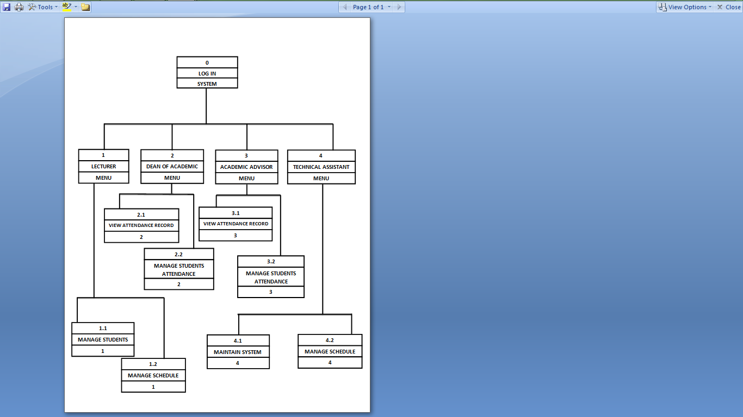

* 1. **Context Diagram**



* 1. **Data Flow Diagram Level 0 (DFD level-0)**

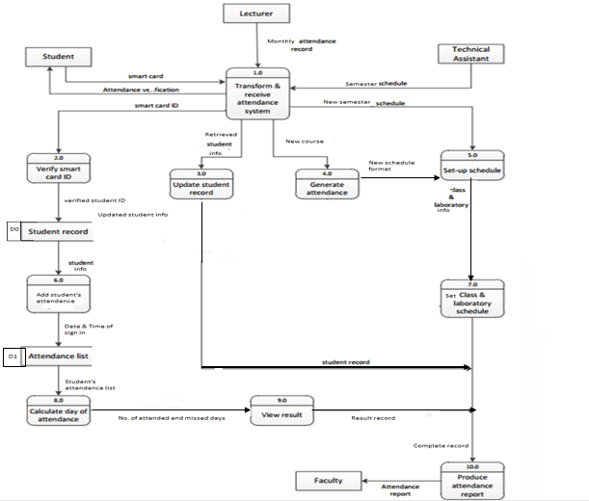

* 1. **Data Flow Diagram Level 1 (DFD level-1)**

**SET-UP SCHEDULE**

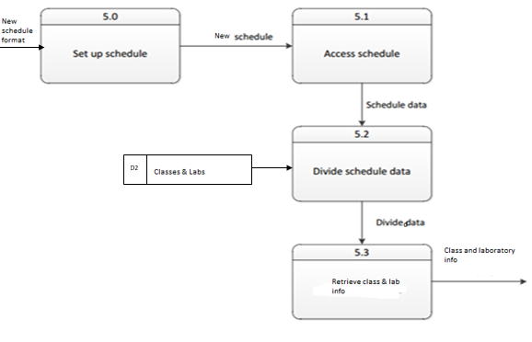

**LAKHVINDER KAUR MAHINDER SINGH (CB14136)**

**ADD STUDENT’S ATTENDANCE**

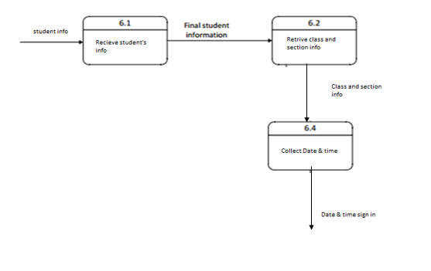

**NUS ASRIN BINTI ROSLI (CA14064.)**

**CALCULATE DAY OF ATTENDANCE**

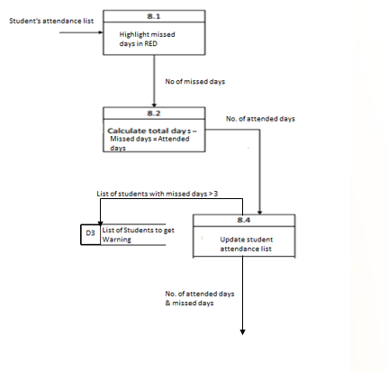

**ATIKA BINTI TALIB (CD14015)**

**PRODUCE ATTENDANCE REPORT**

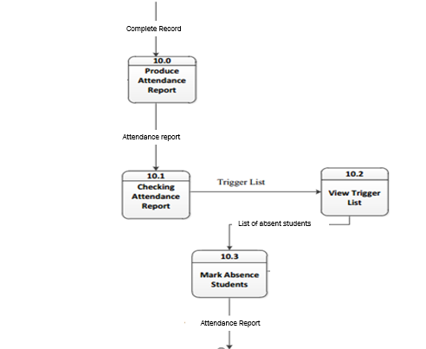

**ZUHURA HASSAN (CB14116)**

* 1. **Use-case Diagram**

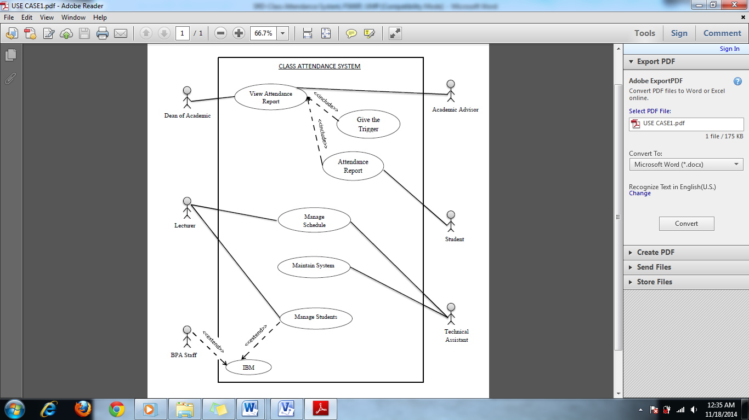

* 1. **Use-case Description**

**2.7.1 Use Case SRD_001**

|  |
| --- |
| Student |

|  |  |
| --- | --- |
| Use Case: | Registration |
| ID: | SRD-001 |
| Scope: | Students attendance |
| Summary: | Student scan smart card ID to record their attendance |
| Primary Actor: | 1. Students |
| Supporting Actors: | 1. Dean of Academic 2. Academic Advisor 3. System Application |
| Precondition: | 1. Scanner must be installing in front of the class or laboratory. 2. Scanner must be set up in a real time mode. 3. Student must use their matrix card. |
| Trigger: | User want to record their attendance |
| Normal Flow: | 1. User scans their smart card ID. 2. User receives verification from the scanner. |
| Alternate Flow/ Exceptions: | 2. a. User’s smart card ID is error.  2. a. 1 User tries again to scan their smart card. |
| Post-Condition: | Attendance are successfully recorded and student can entrance the class |

**2.7.2 Use Case SRD_002**

|  |
| --- |
| Technical Assistant |

|  |  |
| --- | --- |
| **Use Case:** | **Registration** |
| **ID:** | SRD-002 |
| **Scope:** | Manage and maintain system and schedule |
| **Summary:** | Technical Assistant maintains system to make the system always functions and manages the schedule to range the proper schedule based on classes and laboratories. |
| **Primary Actor:** | Technical Assistant. |
| **Supporting Actors:** | 1. System application 2. Lecturer |
| **Precondition:** | The system must be login |
| **Trigger:** | Technical want set up maintain the system and manage the schedule. |
| **Normal Flow:** | 1. The technical assistant set-up the system 2. The technical assistant login based on their category. 3. The technical assistant can choose whether want to manage the system or maintain the system. 4. If the technical assistant choose to manage the schedule then they must manages based on classes and the time. 5. If the technical assistant chooses to maintain the system then they can update the schedule. 6. The technical assistant will maintain the system regularly. |
| **Alternate Flow/ Exceptions:** | 1. The technical assistant cannot login based on category.   1. a. 1 Check connection with database.  1. a. 2 Try login again. |
| **Post-Condition:** | 1. System show the whole schedule based on classes and laboratories. |

**2.7.3 Use Case SRD_003**

Dean of Academic

Lecturer

|  |  |
| --- | --- |
| Use Case: | Registration |
| ID: | SRD-003 |
| Scope: | Monitor and manage student attendance and schedule |
| Summary: | User login into system |
| Primary Actor: | Dean of Academic and lecturer |
| Supporting Actors: | 1. System application 2. Academic Advisor 3. BPA Staff |
| Precondition: | The system application must be login |
| Trigger: | User want to view attendance report and manage student schedule |
| Normal Flow: | 1. User choose the category (exp:lecturer or staff) 2. User enter username and password 3. User access into system 4. User can choose the action    1. User select View Student Report   4.1.1 Loop - User can give trigger to the student and their academic advisor   * 1. User select Manage Student Attendance   4.2.1 User Update Schedule 4.2.2 User Update Student Information |
| Alternate Flow/ Exceptions: | 3a. User cannot access into the system  3a1. User quits site  3a2. User takes action to gain access to the system  4.2.1a. Schedule are clash  4.2.1a.1. User create new schedule 4.2.1a.2. User change the schedule  4.2.2a. Student Information is duplicate 4.2.2a.1. User remove the another one. |
| Post-Condition: | The full attendance record can be view by Dean of Academic and Lecturer |

**2.7.4 Use Case SRD_004**

|  |
| --- |
| Lecturer |

|  |  |
| --- | --- |
| Use Case: | Registration |
| ID: | SRD-004 |
| Scope: | Manage the schedule and students. |
| Summary: | Lecturer manages the schedule to make sure does not have duplicate classes in same time and manages the students to make sure that information of students always being update. |
| Primary Actor: | Lecturer |
| Supporting Actors: | 1. System application 2. Technical assistant 3. BPA staff |
| Precondition: | 1.The system must be login  2. The students have to register the subject and choose the section. |
| Trigger: | The lecturer want to manage the schedule and students |
| Normal Flow: | 1. The lecturer must login based on their category. 2. The lecturer can choose whether to manage the students or choose to manage the schedule. 3. If the lecturer chooses to manage the students, then the lecturer can remove the students who drop the subject. 4. If the lecturer choose to manage the schedule, then the lecturer can range the schedule does not have duplicate classes in same time. |
| Alternate Flow/ Exceptions: | 1. The lecturer cannot login based on their category.   1. a. 1 Send error report to technical assistant. Wait for the respond  1. a. 2 Try login again.   1. The lecturer cannot manage the schedule.   2. a. 1 Send error report to technical assistant. Wait for the respond.  2.a.2 Try again   1. The lecturer cannot manage students.   3. a. 1 Send error report to technical assistant. Wait for the respond  3. a. 2 Try again. |
| Post-Condition: | The system shows the whole schedule and the whole information of students who take the subject. |

* 1. **Activity Diagram**

2.8.1 Activity Diagram for Students Attendance Record

|  |  |  |  |
| --- | --- | --- | --- |
| Student | Scanner | Database  (Student List) | Database  (Attendance Record) |
| View Student ID  Error Smart Card ID  Scan Smart Card ID | Error Verification  Verify Smart Card ID | Invalid user  valid user  Search Student ID | Mark Student Information  Update Student Attendance |

2.8.2 Activity Diagram for Login system (Academic Advisor)

|  |  |  |
| --- | --- | --- |
| Academic Advisor | System | Database |
| System portal  Error notification  Enter username and password  Open the system | Log out the system  Error login  Verify user  Choose Category  Display login page | [If any]  Get trigger  View student attendance  valid user  Invalid user  Search user data |

2.8.3 Activity Diagram for login system (Lecturer and Deputy Dean of Academic)

|  |  |  |
| --- | --- | --- |
| Lecturer/ Deputy Dean of Academic | System | Database |
| Open system  System portal  Error notification  Enter username and password | Select the data  Manage data  Log out the system  Access the system  Error login  Verify user  Choose category  Display login | [If any]  Give trigger  Invalid user  Valid user  Update data  View students attendance  Search user data |

2.8.4 Activity Diagram for login (Technical Assistant)

|  |  |  |
| --- | --- | --- |
| Technical Assistance | System | Database |
| Access the system  Error notification  Enter username and password  Open system | Select the data  Maintain schedule  Set-up Schedule  Access the system  Error login  Verify user  Choose Category  Display login page | Invalid user  Valid user  Update class and laboratory  Update Schedule  Search user data |

* 1. **User Interface**

|  |
| --- |
| **For Student** |
| **Description :** This interface show the student have to scan their smart card id for class attendance system. When they scan their smart card id their picture, name and id will appear to the system. |

|  |
| --- |
| **For Lecture and Technical Assistant** |
| **Description :** This interface show how lectures and technical assistant login to class attendance system. The category button is to choose whether lecture or technical assistant to login. The login describe how lecture and technical assistant to access this system by fill in their id and password. The clear button describe if the lecture or technical assistant want to cancel login. |

|  |
| --- |
| **For Lecture** |
| **Description :** This interface show the menu for the lecturer to choose in this system. The approve list button describe about the list of student name that have approve by lecturer. The update data button describe the student data that lecture can update by section. The view student attendance button describe that lecture can view the student attendance by section. The logout button describe if the lecturer want to out from the form. |

|  |
| --- |
| **For Lecture** |
| **Description :** This interface show the list of student detail that have register to the system from id to subject. The table action have two button that are approve button describe if the lecturer want to approve the student detail for the section and reject button describe if the lecturer want to reject the student detail for the section. The back button describe if the lecturer want to back to main menu. The logout button describe if the lecturer want to out from the form. |
| **For Lecture** |
| **Description :** This interface show the list of students approved by lecturer for the section from id to telephone number. The back button describe if the lecturer want to go to previous form. The home button describe if the lecturer want to back to main menu. The logout button describe if the lecturer want to out from the form. |

|  |
| --- |
| **For Lecture** |
| **Description :** This interface show the update student details that lecturer want for the section. The submit button describe if the lecturer have finish decide the section for student. The back button describe if the lecturer want to go to previous form. The home button describe if the lecturer want to back to main menu. The logout button describe if the lecturer want to out from the form. |

|  |
| --- |
| **For Lecture** |
| **Description :** This interface show the student details that lecturer want to remove for the section from id to address. The back button describe if the lecturer want to go to previous form. The home button describe if the lecturer want to back to main menu. The logout button describe if the lecturer want to out from the form. |

|  |
| --- |
| **For Lecture** |
| **Description :** This interface show the view student attendance that student have register for this system from section to date. The submit button describe if the lecturer want to view the section that student have register. The back button describe if the lecturer want to go to previous form. The home button describe if the lecturer want to back to main menu. The logout button describe if the lecturer want to out from the form. |

|  |
| --- |
| **For Lecture** |
| **Description :** This interface show the list of student attendance that lecturer want to view from id to attendance. The back button describe if the lecturer want to go to previous form. The home button describe if the lecturer want to back to main menu. The logout button describe if the lecturer want to out from the form. The print button describe if the lecturer want to print this list of student attendance for their own data saving. |

|  |
| --- |
| **For Technical Assistant** |
| **Description :** This interface show the main menu for the technical assistant. The view button describe about the schedule for section. The set up button describe about the set up schedule that have been decide from technical assistant. The logout button describe if the technical assistant want to out from the form. |

|  |
| --- |
| **For Technical Assistant** |
| **Description :** This interface show the view schedule that lecturer have order for the section from type of room to date. The view button describe if the technical assistant want to view the schedule that lecturer have been order. The back button describe if the technical assistant want to go to previous form. The home button describe if the technical assistant want to back to main menu. The logout button describe if the technical assistant want to out from the form. |

|  |
| --- |
| **For Technical Assistant** |
| **Description :** This interface show the view schedule that lecturer have been order from type of room to subject. The back button describe if the technical assistant want to go to previous form. The home button describe if the technical assistant want to back to main menu. The logout button describe if the technical assistant want to out from the form. The print button describe if the technical assistant want to print this schedule for their own data saving. |

|  |
| --- |
| **For Technical Assistant** |
| **Description :** This interface show the set up schedule that technical assistant have been decided from type of room to time. The set button describe if the technical assistant have finish set up the schedule for section. The back button describe if the technical assistant want to go to previous form. The home button describe if the technical assistant want to back to main menu. The logout button describe if the technical assistant want to out from the form. |

**3.0 CONCLUSION**

Smart card used in class attendance system can add convenience and safety to any transaction of value and data. An evaluation of performance, cost and security that will produce a smart card system that fits today’s needs in future. This project allows students to easily touch their smart card in order to fill the class attendance. This project also allows the lecturers to get the calculation of the class attendance and view the attendance report throughout by day, month and every semester.